CIG VPN Instructions

1. Run the install  with Administrator privileges
2. Once the installation is done, Goto Start Programs and select “**Check Point Endpoint Connect**”

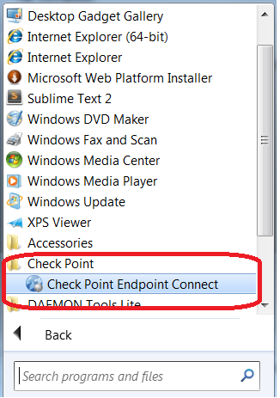

1. Once the **Check Point Endpoint Connect** is selected, you would get the below message

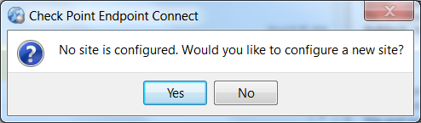

Select Yes, The below screen would be shown

1. **Site Wizard**

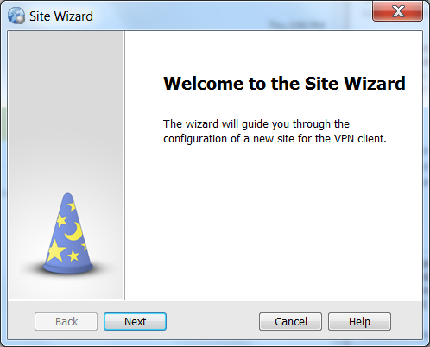

Click Next, The screen "**Welcome to the Site Wizard**" would be shown

1. **Welcome to the site wizard**

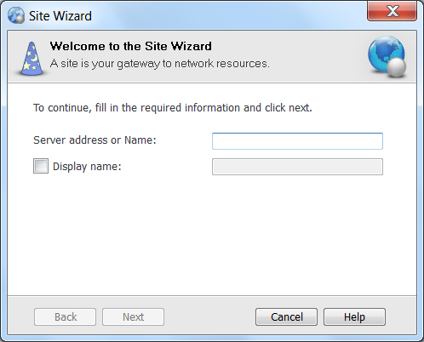

Enter the IP Address 206.197.111.30 in the **Server address or Name**

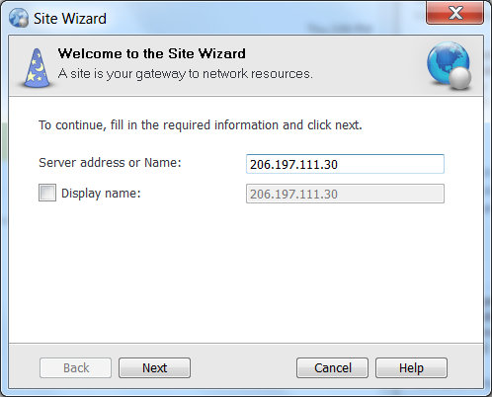

1. Click Next, you will get the below screen, Click OK

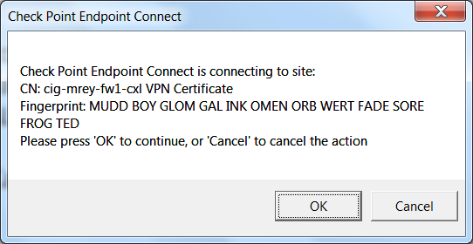

1. “**Authentication Method**” screen would be shown

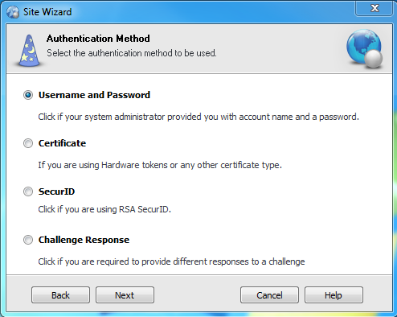

Select Username and Password

1. A final message would be shown as “**Site created successfully**”.



1. Once the site is created, User can make sure the VPN client is running in the system tray, Click on it, and the user would be prompted with the below screen

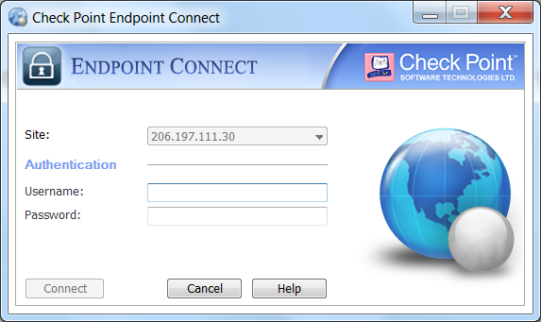

1. Enter user credentials and connect. If the connection is successful, that means you are logged into the CIG network through VPN.